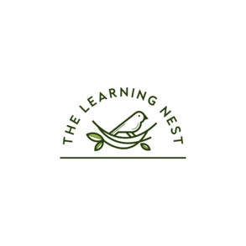

The Learning Nest
Confidentiality, Privacy and Data Retention Policy

Any information given to me, either verbally or in writing, regarding your child or your family, will be treated as confidential.
I am aware of my responsibilities under General Data Protection Regulations (GDPR)
and the Data Protection Act, 2018.
Any information about your family or child is stored digitally with Bethany Jamieson.
Information about your child will not be discussed with anyone else, except those named on
initial agreements (namely parents/carers).
Exceptions can be made where written permission has been given to speak to a named individual either as a one-off or an ongoing basis eg: a grandparent, school or another
tutor your child might be working with.
If these permissions have been given, they can be withdrawn at any time and in that circumstance, no further communication will be made.
I will, however, divulge confidential information to the relevant authorities if there appears
to be a safeguarding issue that potentially affects a child’s welfare and/or safety.
During the course of our working relationship, you will most likely find out information about myself and my family.This information should also be kept confidential in order to respect my family’s privacy. Parents/carers should not discuss any personal information they see, hear or are informed about, with anyone else.

